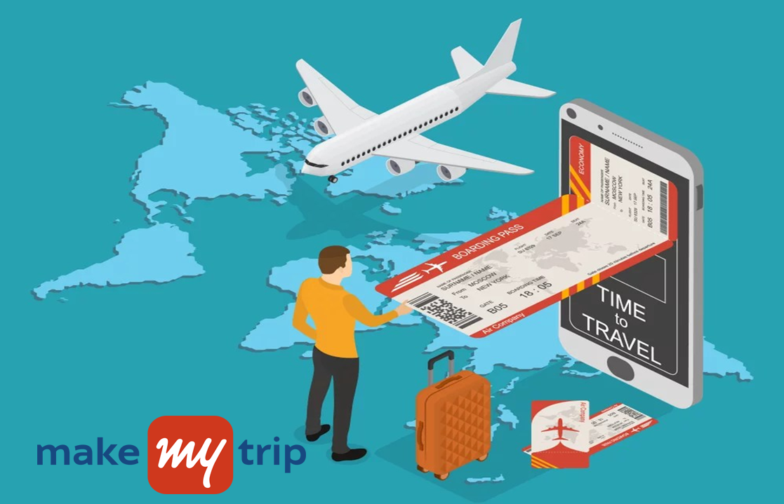

**BOOKING FLIGHT MADE**

**EASY !!**

ONLINE FLIGHT BOOKING PROCESS

1 Makemytrip Flight Booking 3

2 Login/Signup 3

3 Flight Search 4

4 Flight Booking 6

5 Traveller Details 8

6 Flight Seat Selection 9

7 Payment 10

8 Optional Add-Ons for Flight Passengers 11

8.1 Lock Price 11

8.2 Indigo Priority Fast Forward 11

8.3 Airport Pick & Drop 11

8.4 Zero Cancellation 12

8.5 Eat at your Seat 12

8.6 Flight Ticket Fare Category 13

8.7 Flight Insurance 13

# Makemytrip Flight Booking

Makemytrip provides a user friendly online flight booking process for well pre-planned and sudden journeys. Unsure of the trip date, “Lock the Trip” before 7 days for riding in a lower fare. Worried about cancellation charges, Makemytrip offers “Zero Cancellation Fee” by paying certain amount beforehand.

We offer food and cab drop/pickup at the airport Passenger can order food and cab along with the flight ticket. The details of the food menu card and cab price details are listed transparently.

# Login/Signup

Visit [**https://www.makemytrip.com/**](https://www.makemytrip.com/)to book for your flight journey.

Unlike other sites, there is no separate page for Login & Signup Pages. Makemytrip automatically identifies the user by validating the details (Email ID/Mobile Number) provided. If the user is already registered, only OTP is provided. For new users, OTP along with the passenger details has to be provided to complete the makemytrip registration process.



# Flight Search



1. Navigate to “Flights” Tab in the makemytrip homepage by clicking on the Flight Icon. Upon successful selection, the page directs to [**https://www.makemytrip.com/flights/**](https://www.makemytrip.com/flights/)
2. Choose the Trip Type (One Way / Round Trip / Multi City) by selecting the appropriate radio button icon. (In the above example **One Way** is selected)
3. Select the Source & Destination from the drop-down box or manually enter and select through suggestions.

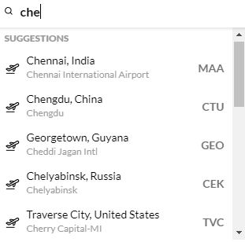

1. Choose the appropriate fare type. (The fare varies for each category)
2. Select the date of journey. The fare is indicated below each date as shown below. (Book earlier to avoid high fares)

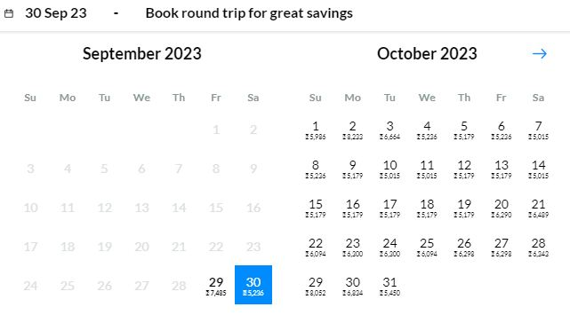

1. Mention the number of passengers travelling. The fare varies for three different category of ages. (Below 2 Years, Age 2-12 Years and Above 12 Years).

Select the Flight Travel Class Type. The fare price increases from left to right. Economy (lowest fare), Premium Economy and Business category (highest fare).

Click “Apply” to save.



1. Click “Search” to view the available flights.

# Flight Booking

* Upon completion of Search, the available flights occur as shown below.
* Select & Filter the flights based on Price, Stops and Timings.
* Passenger can either book immediately or lock the seat based on his/her preference.



* After Clicking Book Now/ Lock Price, the Booking Review window appears as shown below:



* Passenger can apply promo codes for availing further discounts and review the Booking Summary
* Cancellation Refund Policy is also mention in the review panel.
* Click “Continue” to add the passenger details.

# Traveller Details

Add and review the Passenger details (Name, Gender, Mobile No, Email and Residential Address).



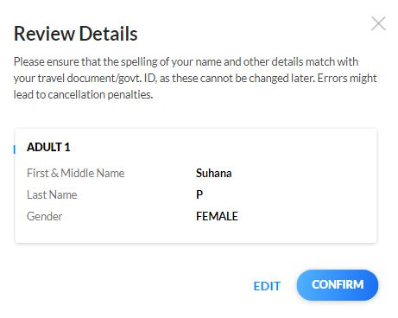

# Flight Seat Selection

Upon successfully reviewing the passenger details, the user is navigated to the “Flight Seat Selection” page as shown below:

The below image denotes the flight’s seat position from top to bottom. Seats denoted with “X” symbol denotes that the seat is already booked. Available seats with their notations (Free, Extra Legroom, Exit Row Seats, Non Reclining and Price Based) are given in bottom left of the picture.



Click “Continue” to proceed to payment.

# Payment

The Passenger can pay through several online payment transactions ( UPI, Net Banking, Credit/Debit/ATM Card, Wallets, Gift Cards, Pay later, EMI and Google Pay). User can also Scan and pay the QR for completing the transaction.

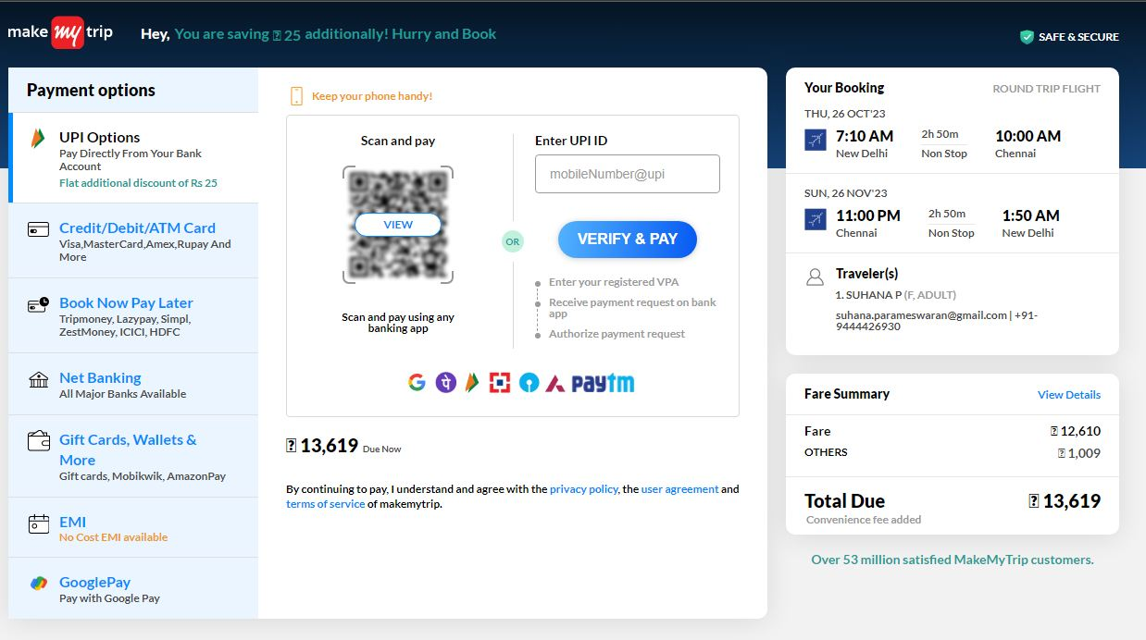

# Optional Add-Ons for Flight Passengers

## Lock Price

Makemytrip allows the passenger to lock the seats before 7 days of departure. The passenger pays for the smallest fare in the final payment. Even if the ticket fare increases after locking the seat, the passenger can pay the amount shown earlier during the locked time. If the fare is decreased at the time of booking, the passenger can pay the same lowest amount for final payment.

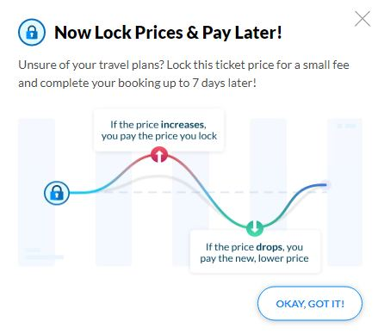

## Indigo Priority Fast Forward

Passenger can avoid the long queue and are given priority for Check-In & Out processes.

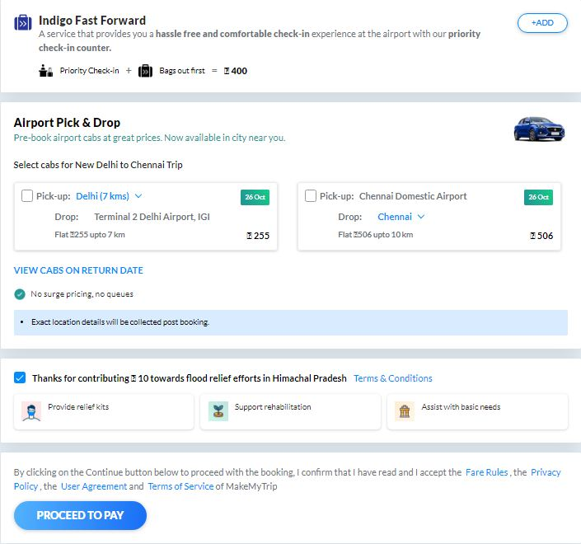

## Airport Pick & Drop

Passenger can view the price and book the cab in advance prior reaching airport.



## Zero Cancellation

Passenger can evade the cancellation fee by paying a smaller additional amount along with the booked ticket, if opted for “Add Zero Cancellation” Add-on.

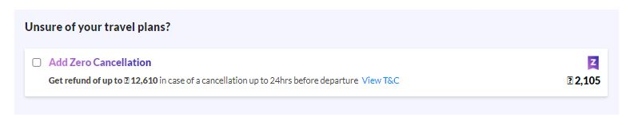

## Eat at your Seat

Passenger can choose the food to be delivered at the flight seat prior journey. The list of available meals is mentioned with prices as shown below. Click “Add” to confirm the dishes of your choice.

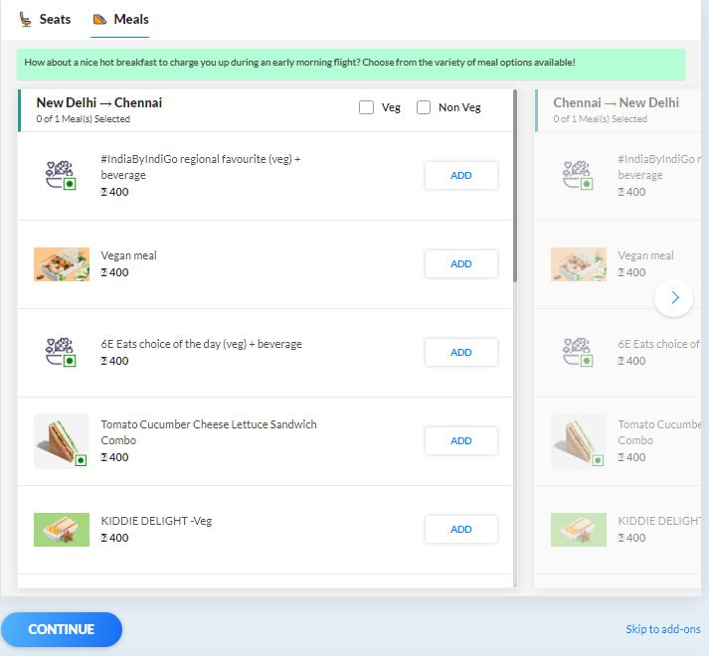

## Flight Ticket Fare Category

Pay higher for more benefits.

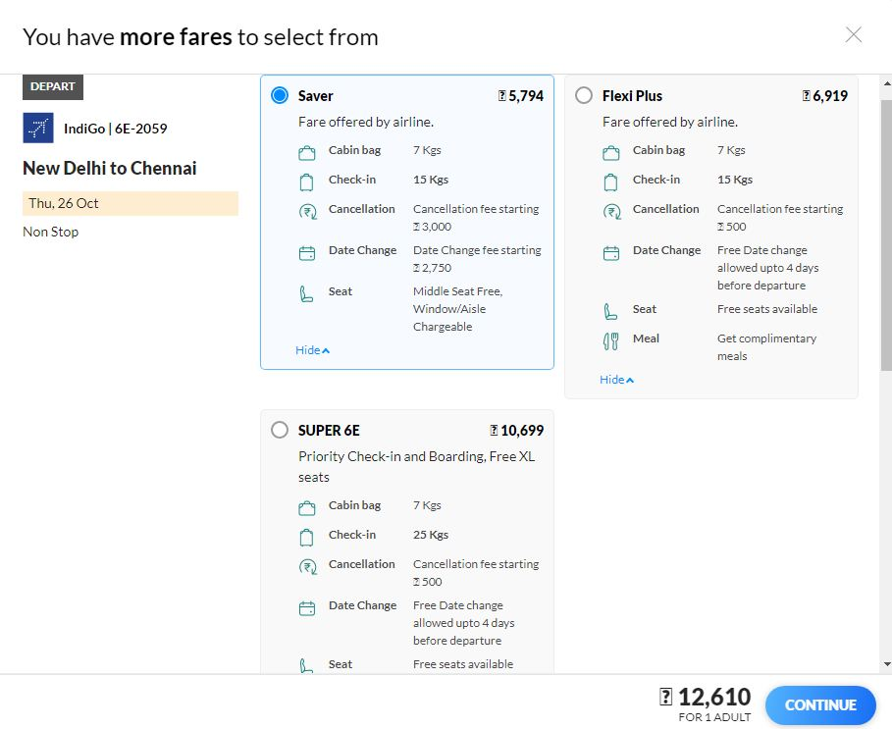

## Flight Insurance

Passenger can opt for Trip Insurance by paying a small amount while booking the ticket.

